Zagazig University

Faculty of Engineering

Department of Computer and Systems Engineering

**Graduation Project Eiraq Web Application**

(Online Learning System)

2020 / 2021

# APPROVAL SHEET

**Title of Project:** Online learning system

**Project Team:** Mohamed Samy Mohamed Mahmoud

Mohamed Hassan Saeed Hamad

Mohammed Ismaiel Ahmed Ismaiel

Mohammed Gamal Mohammed Ali

Abo Bakr Mohamed Mahmoud Salem

Khairy Rabeh Mahmoud Ahmed

Yasmine Kamal El-Sayed Hussein

Fatma Khaled Ahmed Ismael

Alaa Mohammad Ibrahim Metwally

Computer and Systems Engineering, Class of 2021

**Project Approved:** ___________________________

Dr. Hitham Mohammed Abo Bakr

Assistant Professor

Computer and Systems Engineering

**Date Approved:** _________________________

**©** Copyright by

Online learning system team

2021

# ABSTRACT

**Title of Project:** Online Learning System

Online learning system teams, BSc., Class of 2021

**Directed By:** Hitham Mohamed Abo Bakr, Assistant Professor

Department of Computer and Systems Engineering

# Acknowledgements

First, all thanks are due purely to Allah, for providing us the blessings and the strength to complete this project. Second, we would like to express our deepest appreciation to.

**Dr: Hitham Mohamed**

For his guidance through the whole process and for being so supportive and encouraging, God bless you, we cannot thank you enough.

**And above all comes the family**

I would like to thank them for believing in us, giving us confidence, and never getting tired of pushing us forward.

# Table of Contents

Contents

APPROVAL SHEET 2

ABSTRACT 4

Acknowledgements 5

Table of Contents 6

List Of Tables 9

List Of Figure 10

Introduction 11

1.1. System Architecture 11

1.2. Front-End 11

1.3. Back-End 12

1.4. Database 12

1.5. API’s 12

1.6. Version control and deploy project. 13

1.6.1. Version control (GitHub) 13

1.6.2. Deploy Project (Heroku) 13

1. System Architecture 14

1.1. High Level Design 14

1.1.1. Component diagram 14

1.1.2. Activity diagram 14

1.2. Low Level Design 14

1.2.1. Sequence diagram 14

1.3. Entity relationship diagram 14

2. Front-End 15

2.1. Registration Page 15

2.1.1. Sign up. 15

2.1.2. Sign in 15

2.2. Profile Page 15

2.3. Room Page 15

2.3.1. Chat 15

2.3.2. Profile picture 15

2.4. Main page 15

2.5. Join Meeting Page 15

2.6. Scheduling page 15

2.7. Drive page 15

2.8. Private chat page 15

3. Back-End 16

3.1. Registration Page 16

3.1.1. Sign up. 16

3.1.2. Sign in 16

3.2. Room Page 16

3.2.1. Meeting video functionality 16

3.2.2. Meeting info 16

3.2.3. Public chat 16

3.2.4. Share screen 16

3.2.5. Record screen 16

3.2.6. White board 16

3.2.7. Friends 16

3.2.8. Speech to text 16

3.2.9. Raise Hand 16

3.2.10. Services 16

3.2.11. Control on video and Audio 16

3.2.12. End Meeting 16

3.3. Room Page 17

3.4. Main page 17

3.5. Join Meeting Page 17

3.6. Scheduling page 17

3.7. Drive page 17

3.8. Private chat page 17

4. Database And API’s 18

4.1. Registration Page 18

4.1.1. Sign up. 18

4.1.2. Sign in 18

4.2. Profile Page 18

4.3. Room Page 18

4.4. Main page 18

4.5. Join Meeting Page 18

4.6. Scheduling page 18

4.7. Drive page 18

4.8. Private chat page 18

References 19

# List Of Tables

Table 1 information 11

# List Of Figure

Figure 1 Online learning system Architecture 11

Figure 2chat ui 14

# Introduction

## System Architecture

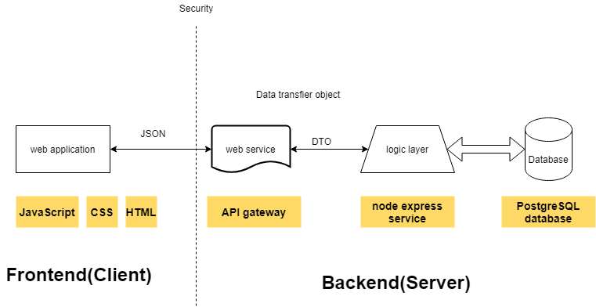

Figure 1 Online learning system Architecture

The architecture explains the components of the system and how the interaction between front-end, back-end and database, and how to transfer data between front-end and back-end. It also explains the languages used in each component.

## Front-End

The front end of the site is everything that the user interacts with. Designed and developed by developers.

One of the most important goals of user interface development is to make the user experience smooth and meet all its requirements easily Therefore, the interface of the application should be intuitive and easy to use.

From some point of view, it may be simple, but in reality, it can be very difficult because not all users or devices are the same.

In this project, the front-end was written using these languages (JavaScript, HTML, CSS, bootstrap, and jQuery).

## Back-End

the "backend" refers to any part of a website or software program that users do not see.

the backend is the "data access layer.

Most modern websites are dynamic, meaning webpage content is generated on-the-fly. A dynamic page contains one or more scripts that run on the web server each time the page is accessed. These scripts generate the content of the page, which is sent to the user's web browser. Everything that happens before the page is displayed in a web browser is part of the backend.

In this project, the Back-End was written using NodeJS and ExpressJs.

## Database

A database is an organized collection of structured information, or data, typically stored electronically in a computer system. A database is usually controlled by a database management system (DBMS). Together, the data and the DBMS, along with the applications that are associated with them, are referred to as a database system.

## API’s

The big advantage of an API is that you can access and use all kinds of different solutions from one system. There is no need to go to all the individual sites or applications to use their functionalities.

In this project we used more than one API, for example google api, Facebook api, twitter api and others.

## Version control and deploy project.

### Version control (GitHub)

### Deploy Project (Heroku)

# System Architecture

## High Level Design

### Component diagram

### Activity diagram

## Low Level Design

### Sequence diagram

## Entity relationship diagram

# Front-End

## Registration Page

### Sign up.

### Sign in

## Profile Page

## Room Page

### Chat

### Profile picture

## Main page

## Join Meeting Page

## Scheduling page

## Drive page

## Private chat page

# Back-End

## Registration Page

### Sign up.

### Sign in

## Room Page

### Meeting video functionality

### Meeting info

### Public chat

### Share screen

### Record screen

### White board

### Friends

### Speech to text

### Raise Hand

### Services

#### Mute all

#### Allow Chat

#### Allow Share screen

### Control on video and Audio

### End Meeting

#### Leave Meeting

#### End For All

## Room Page

## Main page

## Join Meeting Page

## Scheduling page

## Drive page

## Private chat page

# Database And API’s

## Registration Page

### Sign up.

### Sign in

## Profile Page

## Room Page

## Main page

## Join Meeting Page

## Scheduling page

## Drive page

## Private chat page

# References

[This is where you list bibliographic information for any references you made throughout the proposal.]